INFS1200/7900 Module 3 Assignment

Due: 9 October 2020 @ 11:59 PM AEST

Weighting: 10%
 | Full Name | Student ID
Group Member 1 | Xianglong LIN | 45791439
Group Member 2

Overview
The purpose of this assignment is to test your ability to use and apply SQL concepts to complete tasks in a real-world scenario. Specifically, this assessment will examine your ability to use SQL Data Manipulation Language to return specific subsets of information which exist in a database.

This assignment can be completed either in groups of two or individually.

Submission
All submissions must be made through an electronic marking tool called Gradescope, which will also be used for providing feedback. You must record all your answers in the spaces provided in this document. Altering the format or layout of this document in anyway will attract penalties. For group submissions, only one member is required to submit however they must link their partner to the submission in Gradescope. Penalties will apply if this is not completed properly.

Marking
The Module 3 assignment is worth 10 course marks (of 40 course marks total for all four assignments).

Plagiarism
The University has strict policies regarding plagiarism. Penalties for engaging in unacceptable behaviour can range from cash fines or loss of grades in a course, through to expulsion from UQ. You are required to read and understand the policies on academic integrity and plagiarism in the course profile (Section 6.1).

If you have any questions regarding acceptable level of collaboration with your peers, please see either the lecturer or your tutor for guidance. Remember that ignorance is not a defence!

Task
For this assignment you will be presented with the simplified schema of an event management application. The goal of the application is to track both the events attended by users and relationships between users and other users. The system is then able to use this data to effectively market recommended events to users based on the events their friends have attended. You will be required to write 10 SQL queries which answer higher level questions about the data in this database. (Note: Your queries must compile using a MySQL DBMS). A sample database of this system has been provided here which will allow you to test your queries.

Assignment Specification
Events Inc. is a small start-up company which provides its users with an event tracking and recommendation platform for various local community activities. A simplified version of their database schema has been provided below including foreign key constraints.

Relational Schema
User [id, fName, mInitial, lName, age, phone, email, nationality, significantOther]
Event [title, date, description, location, sponsor]
Attends [id, title, date, travelMethod]
Friends [requestor, requestee, startDate]

Foreign Keys
User.significantOther references User.id
Attends.{title, date} references Event.{title, date}
Attends.id references User.id
Friends.requestor references User.id
Friends.requestee references User.id

For this assignment you will be required to write SQL queries to answer to complete the following tasks. Please use the submission boxes provided to record your answers. For queries with a returning relation of more than 10 tuples, you can use the LIMIT 10 clause to only capture the first 10 tuples of the table.
Example
Task | Return the first name and last name of all users.
Explanation | This query should return a table with two columns, one for first name and one for last name.
SQL Solution | SELECT fName, lName  FROM User  LIMIT 10;
Output Screenshot | 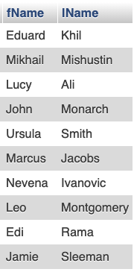

Query 1
Task | Return the first name and last name of all users with an “@uq.edu.au” email address.
Explanation | This query should return a table with two columns, one for first name and one for last name.
SQL Solution | SELECT fName, lName  FROM User  WHERE email LIKE '%@uq.edu.au'  LIMIT 10;
Output Screenshot | 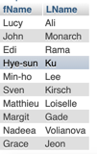

Query 2
Task | Return the number of Korean users who are between 20 and 60 years old.
Explanation | This query should return a table with one column that has a single numerical tuple. The age condition is inclusive meaning Korean users who are 20 or 60 years old should also be included in the total.
SQL Solution | SELECT COUNT(*)  FROM User  WHERE nationality = 'Korean'  AND age >= 20  AND age <= 60;
Output Screenshot | 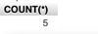

Query 3
Task | Return a list with the number of events each user has attended in descending order of the number of events.
Explanation | This query should return a table with two columns, one for user id and one for the number of events attended by that user. Users who have not attended any events can be ignored.
SQL Solution | SELECT User.id, COUNT(*)  FROM User, Attends  WHERE User.id = Attends.id  GROUP BY User.id  ORDER BY COUNT(*) DESC  LIMIT 10;
Output Screenshot | 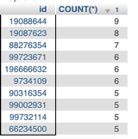

Query 4
Task | Return the names of all users who have initiated (are the requester) of more than 10 friendships.
Explanation | This query should return a table with two columns, one for first name and one for last name.
SQL Solution | SELECT fName, lName  FROM User, Friends  WHERE id = requestor  GROUP BY id  HAVING COUNT(requestor) > 10;
Output Screenshot | 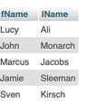

Query 5
Task | Output the full name of each user along with the full name of their significant other. If the user does not have a significant other, those details should be left null.
Explanation | This query should return a table with four columns. The first two should be the first name and last name of a user and the next two should be the first name and last name of that user’s significant other (or null if they do not have one).
SQL Solution | SELECT User1.fName, User1.lName, User2.fName significantFName,  User2.lName significantLName  FROM User User1  LEFT JOIN User User2 on User2.id = User1.significantOther  LIMIT 10;
Output Screenshot | 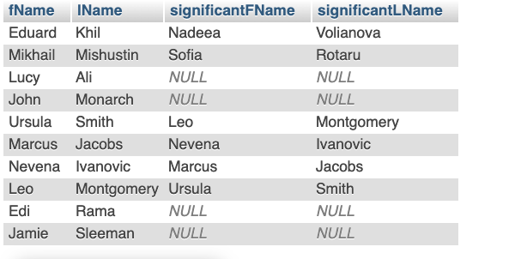

Query 6
Task | Return a distinct list of users who either have a significant other or have attended 3 events by taking the Bus  Note: You must use UNION in your solution.
Explanation | This query should return a table with a single column containing ids of users who meet either of the two conditions described above.
SQL Solution | SELECT DISTINCT User.id  FROM User, Attends  WHERE User.id = Attends.id AND significantOther IS NOT NULL  UNION  SELECT DISTINCT User.id  FROM User, Attends  WHERE User.id = Attends.id AND travelMethod = 'bus'  GROUP BY User.id  HAVING COUNT(*) = 3  LIMIT 10;
Output Screenshot | 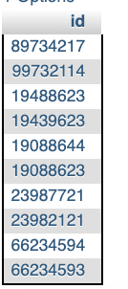

Query 7
Task | Find the total number of users where the nationality of their significant other has at least three people. That is to say, the system has recorded at least three users of that nationality including the significant other.
Explanation | This query should return a table containing a single column which has a single numerical tuple.
SQL Solution | SELECT count(*)  FROM User u1, User u2  WHERE u1.significantOther = u2.id  and u2.nationality in (SELECT u.nationality  FROM User u  GROUP BY u.nationality  HAVING COUNT(*)>=3  );
Output Screenshot | 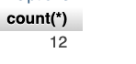

Query 8
Task | Find the oldest friendship started (requested) by each user.
Explanation | This query should return a table containing three columns, the first being the id of a user, the second column being the id of that user’s oldest requested friendship (i.e., the startdate of the requested friendship is the earliest) and the third column is the starting date of the friendship. Users without friends can be ignored.
SQL Solution | SELECT f.requestor, f.requestee, f.startDate  FROM Friends f, (SELECT f.requestor, MIN(f.startDate) startDate  FROM Friends f  GROUP BY f.requestor  ) f1  WHERE f.requestor = f1.requestor and f.startDate = f1.startDate  LIMIT 10;
Output Screenshot | 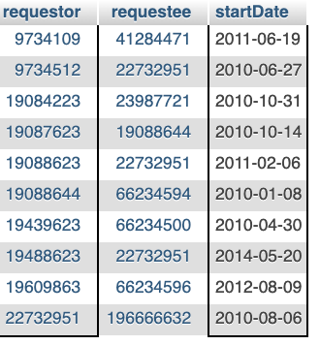

Query 9
Task | Return a list of all the users who have attended at least all the events that “Grace Jeon” has.
Explanation | This query should return a table with a single column of user ids.
SQL Solution | SELECT us.id  FROM User us  WHERE NOT EXISTS (  SELECT CONCAT(e.title, e.date) td  FROM User u, Attends a, Event e  WHERE u.id = a.id  AND e.title = a.title  AND e.date = a.date  AND u.fName = 'Grace'  AND u.lName ='Jeon'  AND CONCAT(e.title, e.date) NOT IN(  SELECT CONCAT(e.title, e.date) td1  FROM Attends a, Event e  WHERE e.title = a.title  AND e.date = a.date  AND a.id = us.id)  );
Output Screenshot | 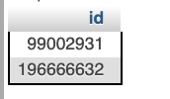

Query 10
Task | Return the title and date of the event which had the most participants.  Note: You must use VIEW in your solution.
Explanation | As above.
SQL Solution | DROP TABLE EventParticipants;  CREATE OR REPLACE VIEW EventParticipants as  SELECT e.title, e.date, a.id  FROM Event e, Attends a  WHERE a.title = e.title and a.date = e.date;  SELECT ep.title, ep.date  FROM EventParticipants ep  GROUP BY ep.title, ep.date  HAVING count(*) = (  SELECT max(num)  FROM (  SELECT count(*) num  FROM EventParticipants ep  GROUP BY ep.title, ep.date  ) t);
Output Screenshot | 